 | Micro-CT Laboratory  A joint operation of the 3D Morphometrics and Bone Imaging Laboratories | 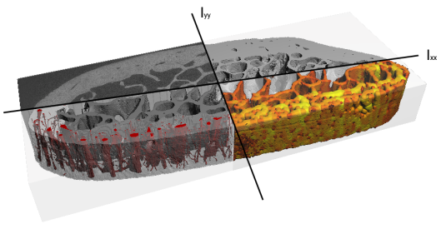

Micro-CT Starter
Package
µCT 35 / vivaCT 40

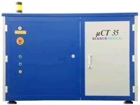 |  | 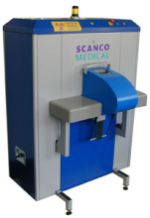

This document was prepared by Helen Buie, 2012-JUN-22.

Contents

Working in HRIC 3A29 3
Authorization to Work in the Laboratory 3
Safety Resources, Supplies, and Disposal 3
Micro-CT Access Application, Fees, and Equipment Bookings 3
Micro-CT Introduction 4
X-Ray Computed Tomography (CT) 4
Micro-CT System 4
Quality Control (QC) 4
Terminology and Files 5
Overview of Micro-CT Workflow 7
Sample Holders, Sample Size, and Resolution 8
Ex Vivo Sample Holders 8
Scan Length and Image Stacks 8
Voxel Size, Sample Holder Diameter and Field of View Diameter 8
In Vivo Sample Holders and Anesthetic System 9
Sample Orientation 9
Project Preparation 10
Workstation Login 10
Log Sheet 10
Setup a Control File (Scan Settings) 10
Standard Operating Procedure 11
In Vivo Scan (vivaCT 40) 11
Ex Vivo Scan (µCT 35/vivaCT 40) 13
Post-Scanning Procedures 14
Backing up RAW Data 14
Evaluating a Scan 14
Results 14
Creating Images and Animations 14
Backing up IMA Data 15
Transferring Files 15
Other Imaging Software 15
ImageJ 15
Amira 15
Osirix 15

Working in HRIC 3A29

Authorization to Work in the Laboratory
All individuals (students, staff, PIs, and academic visitors) wanting authorization to work in the laboratory are required to a participate in a workplace-specific orientation provided by the principal investigator, or their representative, and complete the following courses provided by Environment, Health, and Safety:
- New Faculty & Staff Occupational Health & Safety Orientation
- Generic WHMIS for Laboratories
- Introduction to Biosafety - Module 1
A research worker training record must be completed and signed by the worker and one of the laboratory’s principal investigators (Dr. Steven Boyd, Dr. Benedikt Hallgrimsson, or Dr. Heather Jamniczky) and kept in the laboratory.

Safety Resources, Supplies, and Disposal
You can find resources for working in the laboratory on the website, including safety documents, supplies, and disposal notes.

Micro-CT Access Application, Fees, and Equipment Bookings
All potential clients are required to complete an application form, which will help us to understand the specific needs of the project and facilitate project management. For self-service clients, test scans are required before a project will be approved; the test scans will help the client to effectively design and ensure successful completion of their project. For fee-for-service clients, test scans can be performed to provide a sample of the work that will be done. Fees for use of the micro-CT system are collected to recover costs associated with depreciation of the equipment, for routine maintenance, personnel salaries, system upgrades, and growth of the facility. Bookings for the equipment are made through the online calendar system. Users are expected to abide by the following booking guidelines.

Micro-CT Introduction
This document will provide you with the resources needed to successfully complete your micro-ct project. Web links are provided to reference material, primarily available through the micro-ct website, which can be accessed with your U of C webmail login, or the micro-ct username, and password. If you have problems opening the links in this document, copy the link location into your web browser.

X-Ray Computed Tomography (CT)
Computed tomography is a non-destructive x-ray imaging modality that enables three-dimensional (3D) virtual models of an object to be created. In a CT system, the object is placed between an x-ray source and a detector to acquire projections. Projections are acquired at incremental rotations about the sample. In the µCT 35 the object is rotated for each projection whereas in the vivaCT 40 the object or animal remains stationary and the source and detector are rotated for each projection. Once all the projections have been acquired, the object’s structure is calculated using a method called filtered back-projection. If a sample contains phases with significant differences in x-ray attenuation properties (e.g., bone and soft tissue), the phases can be differentiated in the CT scan. The How Stuff Works website has a nice description of how CT works. Micro-CT refers to CT in which the resolution lies in the micro-scale, which is achieved with a high-resolution x-ray detector and a field of view that is much smaller than conventional CT.

Micro-CT System
There are two micro-ct scanners located in HRIC 3A29, the vivaCT 40 (Fig 1A) for imaging small animals (mice and rats) in vivo, and the µCT 35 (Fig 1B), a specimen scanner. The micro-CT scanners in the lab are manufactured by Scanco Medical and most analyses are performed using Scanco’s software. The micro-CT system operates in OpenVMS, which is a high-end computer server operating system. You may find it useful to familiarize yourself with the OpenVMS system by reading the section on OpenVMS basic commands.

There are currently four micro-ct workstations (Fig 1C), one attached to the vivaCT 40 scanner, one attached to the µCT 35 scanner, and two workstations dedicated for evaluation of micro-CT data. Because the workstations are clustered, you can work on the micro-ct system and your data from any workstation; you can even remotely connect and work from your office or from home. The workstations connected to the scanners are primarily used for scanning, but can also be used for evaluation purposes if the other workstations are in use. Micro-CT data is stored initially on a disk array (Fig 1C), which is configured as a RAID system. If you notice a red light on any of the disks in the disk array, please report it ASAP. A tape drive (Fig 1D) is used to backup data.

Quality Control (QC)
Quality control of the micro-CT image data is ensured by scanning a phantom (Fig 1E) of known densities and checking that consistent values are being obtained over time. Density values are calculated from a previously established linear calibration of densities to grayscale values (system calibration). If the calibration check values deviate by ± 2.5% from the known reference value, then the phantom is scanned repeatedly and a new linear calibration (i.e., a new slope and intercept) is determined and the system calibration is updated by the user. The calibration check and update where appropriate, are performed on a weekly basis by a designated person in the lab. Other users may perform QC checks, but it is not necessary.

 |  | 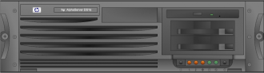  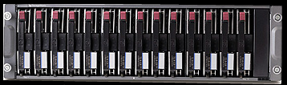 | 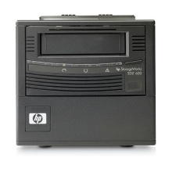 | 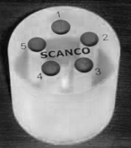
A) vivaCT 40 | B) µCT 35 | C) computer and disk array | D) tape drive | E) QC phantom

Figure 1: Components of the micro-ct system in HRIC 3A29.

Terminology and Files
As a user of the micro-CT system, you should be familiar with terminology associated with micro-CT, see Table 1, and the files that will be produced, see Table 2.

Table 1: Terminology associated with micro-CT.
What | Sample Image
Dark Field  Detector response without x-rays. Enables corrections of non-uniformities of the detector. Acquired automatically by the scanning software before each scan. | 
Bright Field  Detector response with x-rays but no sample. Enables corrections of non-uniformities of the x-ray beam. Acquired automatically by the scanning software before each scan. | 
Raw Projection  A raw x-ray projection of a mouse leg. The darker regions correspond with higher x-ray attenuation. The discontinuities result from overlaps where the detector was shifted to acquire the large region of interest. Projections are acquired at many incremental rotations around the sample. | 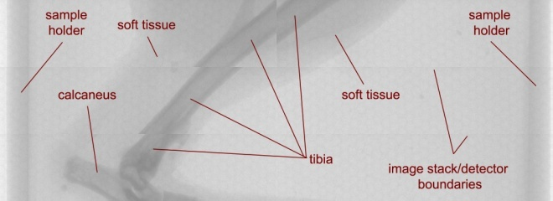
Attenuation Projection  Calculated x-ray attenuation caused by the sample after correcting for the inhomogeneities of the detector (i.e., using the dark field) and beam (i.e., using the bright field). Bright regions correspond with higher attenuation. | 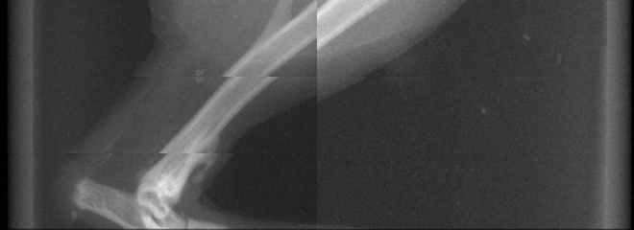
Reconstructed Image  From the attenuation projections, the original structure is calculated using filtered back projection.  Examples of the reconstruction process can be found on the web:  - human midsection  - human head | 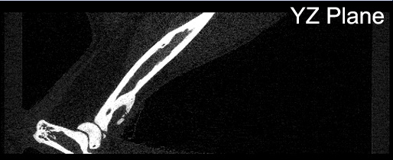
Sinogram  The sinogram is a different representation of the projection data. The sinogram represents the attenuation values of one row of the detector at each rotational increment around the sample. | 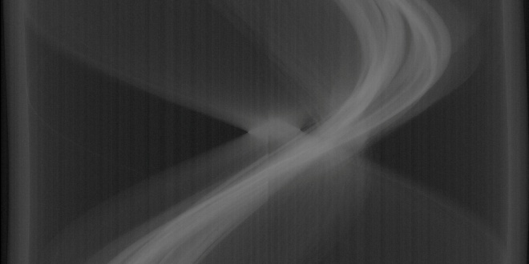

Table 2: File types for Scanco Medical AG micro-CT systems.
File Extension | Definition | Description | Associated Program | Data Backup  Classification
SCV | SCout View | The scout view is an image, similar to an x-ray, which is obtained before the scan to set the scan region. | XImage | IMA
RSQ | Raw SeQuence file | This file contains the average dark field and bright field images and the raw projections. This data is saved to disk immediately following a scan. | XImage | RAW
ISQ | Image SeQuence file | This file contains the reconstructed image data and is usually generated within about 24 hours of scanning. | µCT Evaluation | deleted
GOBJ | Graphical OBJect file | This is a file containing contours (i.e., lines), provided by the user, to define a region of interest (ROI) in the scan. These contours are used in the analysis of the scan data. | µCT Evaluation | IMA
AIM | Any IMage type | AIM files are evaluation files and includes grayscale data, segmented (i.e., binary) data, thickness distributions, and so on. Normally the AIM files consist of a sub-region of the ISQ unless the scan ROI fills the entire field of view of the scan. | µCT Ray | IMA

Overview of Micro-CT Workflow
Figure 2 provides an overview of the micro-CT workflow. Each task links to additional details on the lab website.
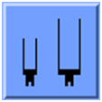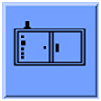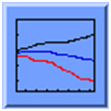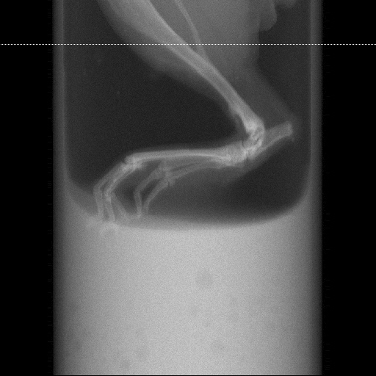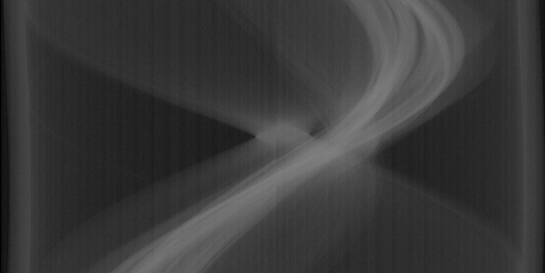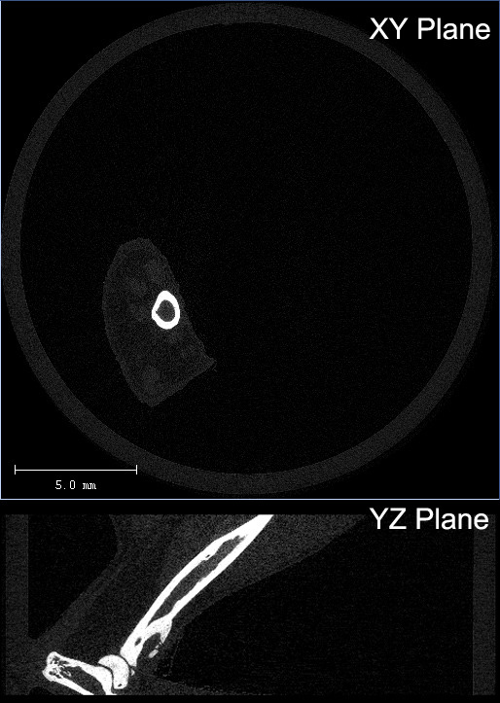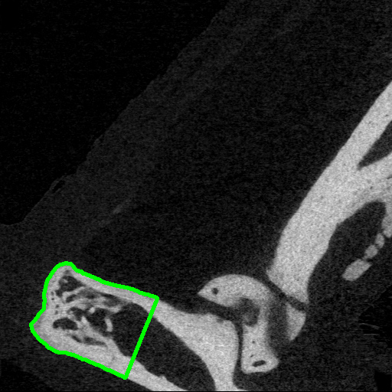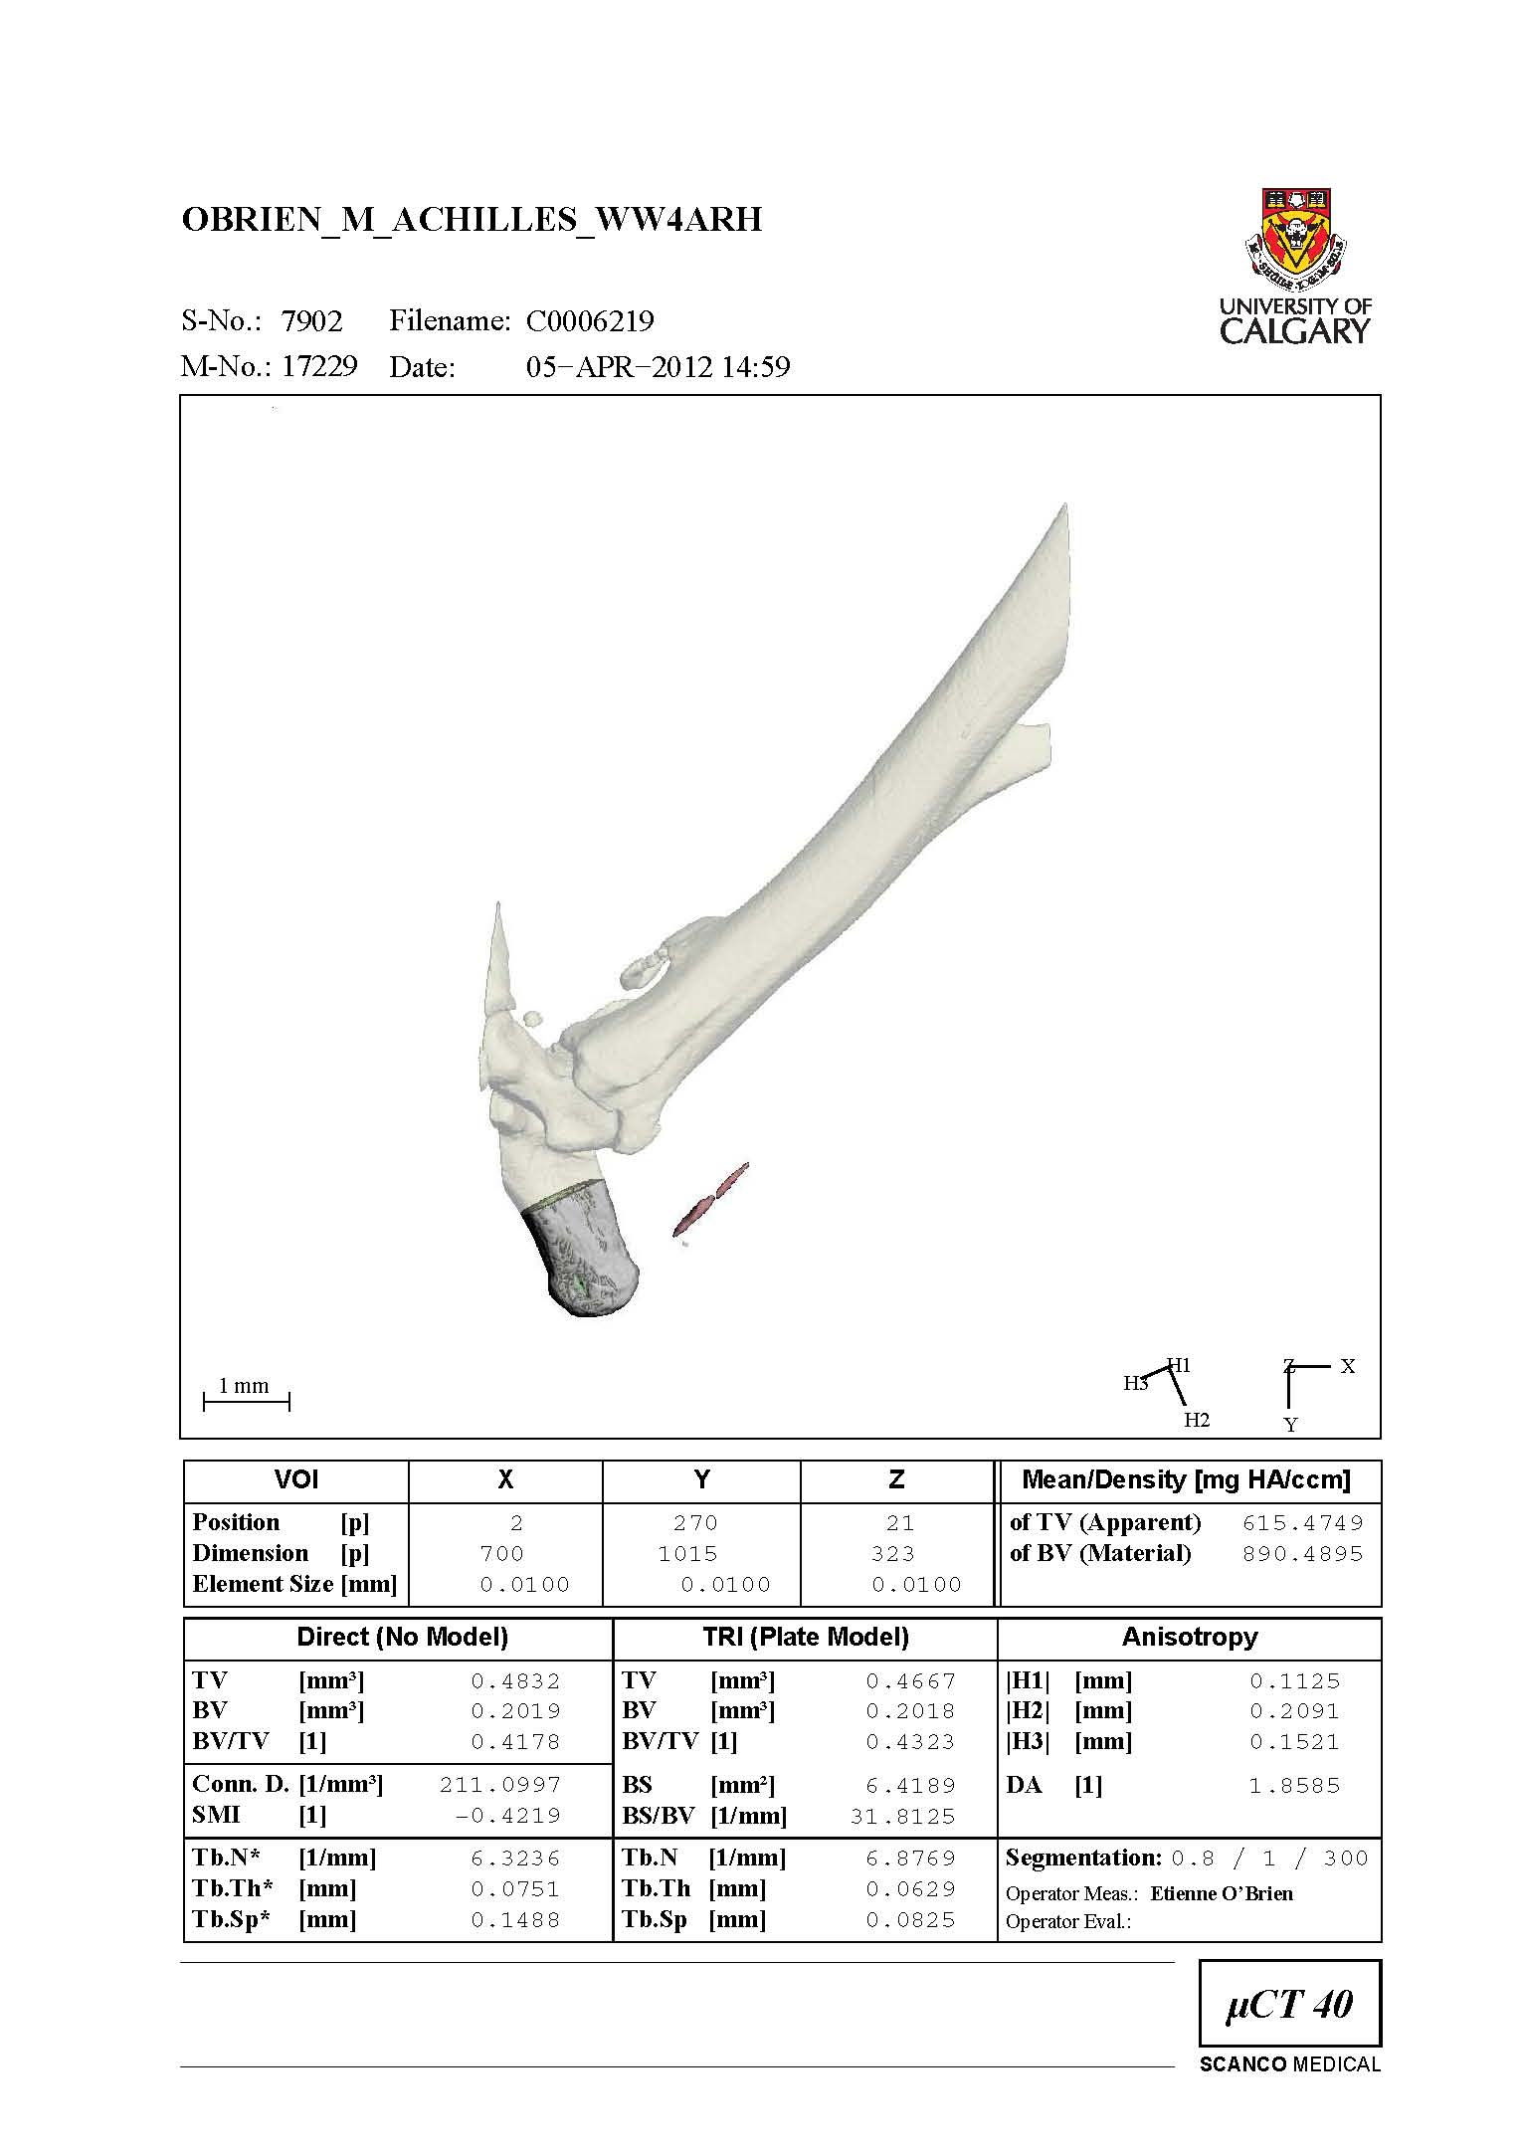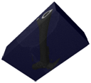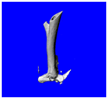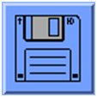
register

scout view

scan

scout view

contour

scout view

scout

scout view

set scan
region

scout view

start
scan

scout view

.SCV

scout view

input sample name/details

sample number is assigned

.RSQ

scout view

.ISQ

scout view

reconstruction job is automatically submitted to SYS$SLOW queue

scout view

open file scan

scout view

.GOBJ (green line)

scout view

contour ROIs

scout view

choose and
start a 3D
evaluation task

.AIM
(grayscale ROI)

scout view

_SEG.AIM
(binary ROI)

scout view

reconstruct

scout view

analysis
script

scout view

evaluation job is automatically submitted to SYS$FAST queue

ROI is “cut out”
Gaussian smoothing
and thresholding
other measurements
(volume, density, etc)

scout view

measurement number
is assigned

archive

scout view

backup RAW

scout view

backup
IMA

scout view

backup IMA data after analyses are complete and images for any figures are saved

backup RAW data
after reconstruction
(i.e., after the ISQ file has been created)
Figure 2: Overview of the micro-CT workflow.

Sample Holders, Sample Size, and Resolution
When preparing your samples for CT scanning, there are some things to keep in mind:
- With smaller sample diameters, better resolutions are possible or shorter scan times.
- Sample holders are positioned vertically in the µCT 35 and horizontally in the vivaCT 40.
- Holders containing liquid must be sealed to prevent spillage in the scanner.

Ex Vivo Sample Holders
Specimens are scanned in sample holders, as shown in Figure 3. The sample must be contained within the holder so that the sample does not interfere with acquisition of the dark field and bright field images. If the sample is to be scanned in liquid or kept hydrated, then the sample holder must be sealed to prevent evaporation and accidental spilling in the scanner. Biological samples are scanned in the yellow holders (see chemical resistivity of holders).

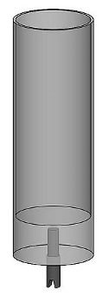 |  | 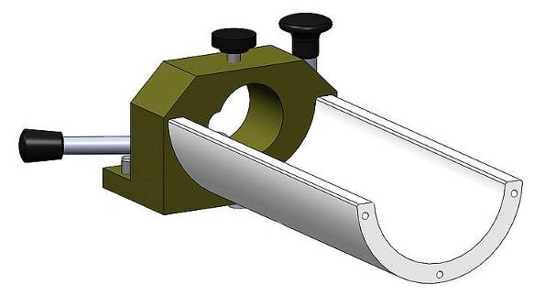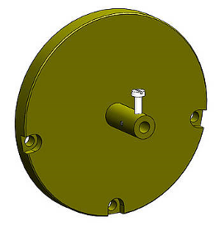  +  +
µCT 35 |  | vivaCT 40

Figure 3: Ex vivo sample holder setup for the µCT 35 and vivaCT 40 scanners.

Scan Length and Image Stacks
Scans are acquired in image stacks (see Figure 4), the height of which is determined by the number of vertical pixels in the detector array. If a longer scan length is desired than the image stack height, then the detector is shifted to enable multiple image stacks to be acquired.

Voxel Size, Sample Holder Diameter and Field of View Diameter
The voxel size of the scan is determined by the diameter of the field of view and the number of horizontal pixels in the detector array (see Figure 5). The size of the field of view is one of a number of scan parameters that can be modified and will influence the distances between the x-ray source, object, and detector. The sample holder used must fit within the diameter of the field of view; otherwise you will end up with image artifacts, increased image noise, and incorrect density measurements. The sample holders come in a variety of diameters that correspond closely with the field of view diameter settings, which differ for the vivaCT 40 and the µCT 35.

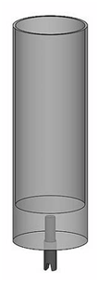  sample holder  diameter (D)  scan  length  image stack  height =  vert detector pixels |  | D  D  voxel size = field of view diameter / horiz detector pixels  detector  x-ray source  sample holder
Figure 4: Sample holder for ex vivo scans illustrating how multiple image stacks are used to scan large samples. |  | Figure 5: Top view of sample holders demonstrating how smaller sample holders, and therefore smaller samples, can yield a finer voxel size.

In Vivo Sample Holders and Anesthetic System
There are currently four in vivo scanning fixtures, three for mice, and one for rats. The rat tibia fixture, mouse tibia fixture, and mouse lower limb fixtures are adapter plates that connect to the animal beds. The mouse whole body tube attaches directly to the track on the vivaCT 40. More detailed information on these in vivo fixtures can be found on the website as well as information on using the anesthetic system.

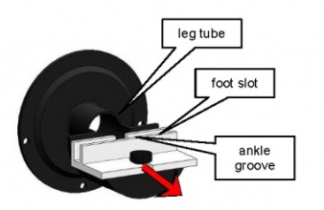 | 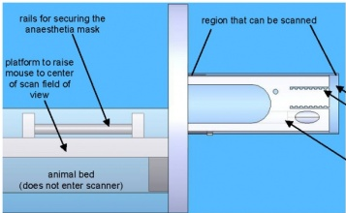
rat and mouse tibia fixture | mouse lower limb fixture | animal bed

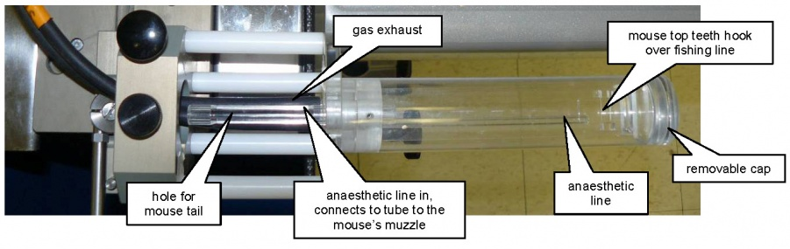
mouse whole body tube fixture

Figure 6: In vivo scan fixtures.

Sample Orientation
Consistent sample orientation often facilitates analyses and image processing. If samples are oriented with the image axes, file sizes are also kept to a minimum, which reduces data storage and memory requirements for analyses. Figure 7 shows the perspective of the reconstructed image. For the µCT 35, the cross-sectional view is standing at the front of the scanner and looking down from above. For the vivaCT 40, the cross-sectional view is from the back of the scanner and looking towards the front.

Figure 7: Cross-sectional (XY) plane and perspective for scans with the µCT 35 and vivaCT 40.

Project Preparation

Workstation Login
Once your test scans or micro-CT application is approved, you will be provided with a username and password to access the system. Do not share this login information with others.

Username:
Password:

Log Sheet
Each scan acquired on the micro-CT system is tracked on a log sheet. Here you will record important information such as sample and measurement numbers. The log is kept in a binder in the laboratory. It is recommended that each user also keep a personal copy of their log sheet.

Log sheet templates are available from the website.

Setup a Control File (Scan Settings)
The scanner settings are specified in the scanner control file and will influence the image resolution, image quality, radiation dose, and duration of a scan. A minimum of 4 voxels should represent the smallest element of interest in the scan. You should use the minimum resolution and image quality necessary to adequately address your research question. Data size and scan times increase rapidly as the voxel size decreases and x-ray tubes are expensive to replace!

Energy (E): | lower energies = better contrast, higher energies = better signal to noise ratio (SNR)  45 kVp for examining soft tissue (e.g. embryos) and low density materials  55 kVp for in vivo and ex vivo scans of bone  70 kVp for ex vivo bone scans and high density materials
Current (I): | use the highest option that yields a power in Watts (W) less than the resulting voxel size  Power [W] = Energy [V] × Current [A]
Diameter: | choose the smallest field of view (FOV) that will fit the sample holder, or the scan region for in vivo fixtures
Resolution: | choose high, medium, or standard resolution to yield the desired voxel size
Integration Time: | lower values = faster scans, higher values = better image quality  ~200 ms is typical for in vivo scans  ~400 ms is typical for ex vivo scans
Average Data: | increase value to reduce noise only if the integration time is maxed out
Calibration: | 1200 mg HA/cm3 is used for bone  plexi is used for soft tissue where no bone is present (e.g., embryos)

Standard Operating Procedure

In Vivo Scan (vivaCT 40)
Prepared by: Helen Buie
Date: 2012-JUN-21

Before the scan day:
- Check supplies (the two f/air filter, oxygen tank and isoflurane levels, ophthalmic ointment) and restock if necessary and dispose of used items. Also check that the in vivo scanning fixture that will be used is in good working condition.
- Register samples for scanning.
- see the sample naming convention
- register samples using the µCT-Samples program
- record sample names and numbers on your log sheet
- Setup a control file. Use the planning document to estimate your scan dose.
- mice: CTDI_{water} = 145 – 235 mGy/wk is okay; 480 mGy/wk may cause bone loss!
- Book the vivaCT 40 scanner.

On the scan day:
- If necessary, turn on the scanner and open the scanning program to start the 20 min warm up.
- Check the two f/air filters. There is one filter on the wall, which attaches to the anesthetic chamber, the other filter is by the vivaCT and connects to the auxiliary anesthetic line. If the filters have absorbed 50 g of anesthetic, replace it with a new filter and dispose of the old filter.
- Attach the in vivo scanning fixture to the track, connecting the anesthetic lines and/or rodent masks. Be sure to connect the anesthetic and exhaust lines correctly.
- Prepare the anesthetic system.
- line the chamber with a piece of paper towel and close the lid
- connect the chamber anesthetic line and exhaust
- switch on the toggle for the chamber (toggle for the auxiliary line is off)
- fully open the valve for the oxygen tank
- turn the oxygen tank gauge to 15 (maximum)
- adjust the oxygen flow rate to 1 L/min (usually it is always set to this level)
- set the isoflurane level (1.0-1.5 v/v% for mice; 1.5-2.0 v/v% for rats)
- Anesthetize the animal.
- place the rodent into the chamber and wait 30-60 s for it to fall asleep
  - increase isoflurane by 0.25 v/v% if animal is resistant
  - decrease isoflurane level if the animal’s breathing is rough
- when the animal is asleep, switch on the toggle for the auxiliary line
- if using the whole body fixture, apply the ophthalmic ointment to the eyes
- wait 1-2 min to minimize the risk of the animal waking up
- Transfer the animal to the scan fixture.
- remove the animal from the chamber
- switch off the toggle to the chamber
- place the animal into the scan fixture and, if applicable, affix the anesthetic mask
- apply the ophthalmic ointment to the eyes to prevent dryness
- prepare the animal for scanning in the in vivo fixture to minimize motion
- Scan.
- if it is the first scan
  - login to the workstation with the invivo user account
  - put in your operator number or name
  - start the scanning program
  - select the control file
- select the sample number for the animal
- perform a scout view
- place reference line and start the scan
- record the measurement number on log sheet
- Check the scan quality and scan again if necessary.
- after the scan, check the quality of the reconstructed preview
- if there are motion artifacts, scan again
- Repeat steps 11-12 for additional scans of the animal.
- Post-scanning procedures.
- switch off the toggle for the auxiliary tube
- switch on the toggle for the chamber
- remove the animal from the scan fixture
- ear notch the animal with an ID number if necessary
- weigh the animal
- allow the animal to wake up (typically within 2-3 min) away from other animals, e.g., in a beaker or separate cage
- Repeat steps 9-14 for additional animals.
- Clean-up.
- turn off isoflurane
- turn off oxygen gauge and valve
- remove anesthetic chamber and in vivo fixture and clean with dish soap
- close the scanning program
- log out of the workstation

Standard Operating Procedure

Ex Vivo Scan (µCT 35/vivaCT 40)
Prepared by: Helen Buie
Date: 2012-JUN-21

Before the scan day:
- Register samples for scanning.
- see the sample naming convention
- register samples using the µCT-Samples program
- record sample names and numbers on your log sheet
- Setup a control file. Use the planning document to estimate your scan time and file size.
- Book the µCT 35 or the vivaCT 40 scanner.

On the scan day:
- If necessary, turn on the scanner (µCT 35/vivaCT 40) and open the scanning program to start the 20 min warm up.
- Prepare the sample(s) in the ex vivo holder and place the holder in the scanner.
- orient your samples sensibly and consistently in the holder
- if multiple samples are placed in the tube, make notes of the order of the samples in the holder
- Perform a scout view.
- if it is the first scan
  - login to the workstation
  - put in your operator number or name
  - start the scanning program
  - select the control file
- select the sample number
- perform a scout view
- Place a reference line and submit scan (interactive/batch).
- use the batch mode if you have multiple samples in the holder and for long scans (avoids the possibility of someone accidentally cancelling the scan)
- Record the measurement number on the log sheet.
- Repeat steps:
- for batch scans (multiple samples in the holder or multiple scan sites of a single sample), select a new sample number and repeat steps 7-8
- for new samples, repeat steps 5-8
- Post-scanning procedures.
- disinfect the ex vivo sample holder or wash with dish soap, as appropriate
- close the scanning program
- if performing batch scans, request an email notification when the scans are done
  - in the terminal $ @com:email
- log out of the workstation

Post-Scanning Procedures

Backing up RAW Data
Usually within a couple hours to a day after scanning, the scan data will be reconstructed. If your sample is poorly aligned with the axes of the image, you will want to re-reconstruct the sample at a prescribed angle. Once reconstructed, the RSQ file is no longer needed and you should perform the RAW backup using the µCT Disk-Utility program.

Evaluating a Scan
Scans are evaluated using the µCT Evaluation program. Standard evaluation scripts are available for import from Scanco Medical. It is also possible to write a custom evaluation script in Scanco Medical’s Image Processing Language (IPL). Some example scripts with comments can help get you started with scripts: IPLV6_VOI.COM, IPLV6_TRABECULAR_BONE.COM, and IPLV6_MIDSHAFT.COM.

Once you have decided on an evaluation, you will generally need to contour regions of interest for the analysis. You’ll want to check out the summary of the contouring tools available in the evaluation program. To ensure that you perform the contouring and analysis consistently, you should prepare a protocol for the evaluation with detailed descriptions and/or images for each step. You may want to remotely connect to the micro-CT system to take screen shots for your protocol.

Results
Results are stored in a database on the micro-CT system. If you ran one of the standard Scanco Medical evaluation scripts, then the results are likely already extracted to a results directory, the location of which will depend on the user account used for the scanning and evaluation. Results can be extracted from the database using the uct_list tool.

If you are performing a bone analysis, you will want to familiarize yourself with bone densitometry and morphometry.

Creating Images and Animations
The µCT Ray program is used to visualize the micro-CT data in three-dimensions (3D), see Figure 8, and can be used to save an image for a figure or multiple images to combine into an animation.

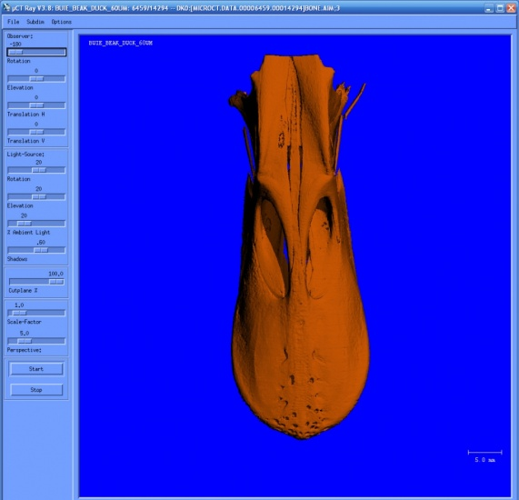
Figure 8: Visualization of duck beak in 3D.

Backing up IMA Data
Once you have completed your evaluation(s) and created any images or animations you need, you may want to copy your data to a server, then it’s time to backup the image (IMA) data.

Transferring Files
The OpenVMS system uses a file versioning system (e.g., Myfile.AIM;1, Myfile.AIM;2), which poses problems for many file transfer protocols (FTP), which cannot properly remove the version number. The following programs are recommended to users for transferring their files from the micro-CT system:

Windows:
- Scanco Medical MicroCT FTP
- Filezilla 2.2.32 (The newer version of Filezilla will not remove the file version number.)

MAC/Linux:
- Fetch
- FTP from the terminal

Other Imaging Software
Scanco Medical’s grayscale AIM files are stored as 16-bit signed little Endian data and can usually be read by programs with a raw data reader if the user provides the data dimensions, resolution, and header offset. You will need transfer the files from the micro-CT.

ImageJ
Plugins to read the Scanco Medical file types are available for ImageJ, which is a free-program and can be used to convert the data to other formats and perform image processing and analyses.

Amira
Here is an example script to write an Amira Tcl command to open AIM files using Amira’s raw reader. This program can be used to landmark data for morphological analyses.

Osirix
Data can be imported into Osirix for viewing or archiving using the Import Raw Data command (FileImportImport Raw Data…). The example Amira script can be used to export the AIM file header as a text file so that you know the parameters required to import the data successfully.
- Rows = dim Y, Columns = dim X, Slices = dim Z
- Pixel Height, Pixel Width, and Slice Thickness = element size X, Y, Z
- Offset = offset to the start of the image data
- 16 bit signed grayscale little Endian

